**SITE PLANNING**

***TEMPLE INN & SUITES***



***SITE NAME***

My proposed site name is [www.TempleInnAndSuites.com](http://www.TempleInnAndSuites.com) a domain which is available for $12.00 per year.

***SITE PURPOSE***

The purpose of the site would be to provide allow potential guests to book their accommodations and plan their temple visits, whether for short term or long-term visits. Also, to share information regarding other services for events that are offered.

***TARGET AUDIENCE AND SCENARIOS***

## Fictitious Persona #1 & 2: President and Sister Kupu.

(https://zambialusakamission.weebly.com/mission-president.html) are a senior missionary couple who need a place to stay while on their trip to the temple in south Africa, Johannesburg. Their needs are simple, but there are some dietary restrictions that are easier to deal with if they are able to cook for themselves.

 Fictitious Persona #3 & 4: Anja and Lukas (https://www.churchofjesuschrist.org/media/image/african-couple-6a1e2b2?lang=eng) are a young engaged couple planning their temple wedding from Senegal. The nearest temple to them is in Ghana, and they have many family members who are eager to see them sealed for eternity. A place to get ready is a must for their special day.



Fictitious Persona #5: (https://www.google.co.za/) Efua Traore is a youth leader in her small branch in Nigeria. She has been tasked to organize a youth temple trip for her branch, and needs to not only organize transportation, but accommodation. Free breakfast is a requirement, and entertainment (swimming!) is a bonus.

***FUNCTIONAL SPECIFICATIONS***

Required functional specifications:

• Site must be responsive to small, medium, and larger wide screen views.

• Design is consistent throughout the website, providing ease of navigation and supports excellent user experiences.

• The home page is a contemporary, exciting landing page providing images of temples and temple attending activities and must include the following: ⇒ A call to action to make a hotel reservation ⇒ Readily available navigation and contact info for the hotel chain ⇒ Summary information about a temple of your choosing

• The temple page describes the details for at least four temples of your choice providing information about the address, telephone, email, services, history, ordinance schedule, session schedule, temple closure schedule (from a JSON source) and summary—current weather information obtained from a third-party API.

• The reservation page contains a form that collects relevant information when making a normal stay reservation including the location, date, number, and type of rooms, registrant’s full name, email, phone, home state or country, and special accommodations/comments.

• The services page provides a list with information of the amenities and special services offered at the hotel along with the following subpages/content: ⇒ The reception page displaying information about the wedding reception accommodations, including options for food service and setup. ⇒ A full-time temple missionary page w/info + images about the suites offered with a Contact Us form.

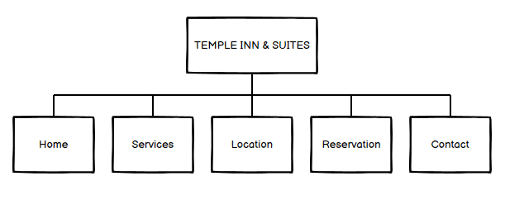***SITE MAP***

***Wireframe sketches: small view***

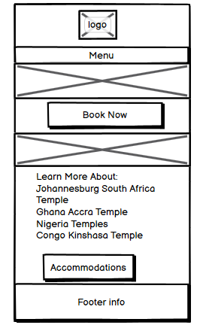

***Wireframe sketches: medium view***

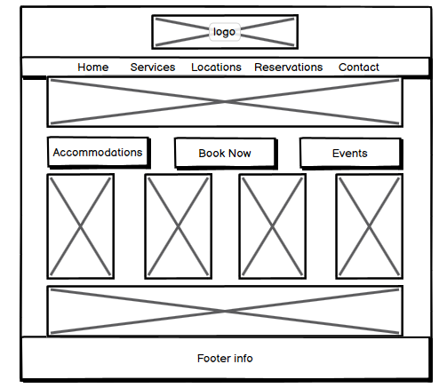

***Wireframe sketches: large view***

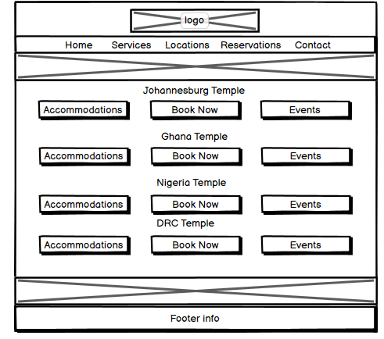

***COLOR SCHEME***

The main color will be Teal, which lighter shade closely matches the icons from the main Temple website.

<https://coolors.co/ffffff-cacfd4-f2be54-03324e-000000>

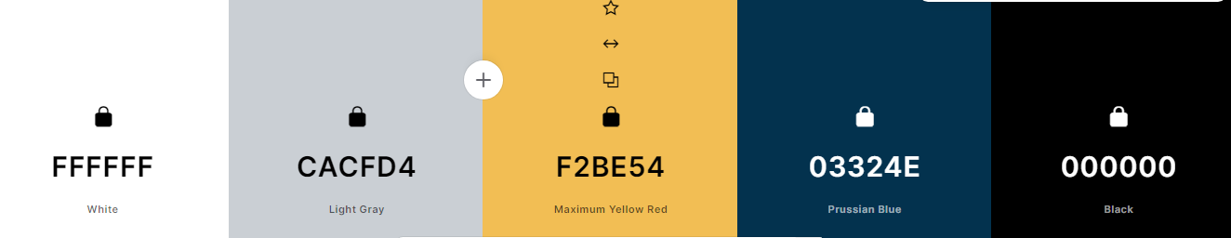

### ***TYPOGRAPHY***

|  |  |  |  |  |  |
| --- | --- | --- | --- | --- | --- |
| **Content** | **Font** | **Font Size** | **Font Color** | **Background Color** | **Sample** |
| Site Header | Roboto | 40px | #ffffff | #153e5c | Sample |
| Primary Navigation | Roboto | 20px | #000000 | #f2be54 | Sample |
| Footer Navigation | Roboto | 20px | #000000 | #f2be54 | Sample |
| Heading 1 (h1) | Roboto | 30px | #153e5c | #ffffff | Sample |
| Heading 2 (h2) | Roboto | 25px | #153e5c | #ffffff | Sample |
| Heading 3 (h3) | Roboto | 20px | #153e5c | #ffffff | Sample |
| Paragraph text (p) | Roboto | 16px | #000000 | #ffffff | Sample |